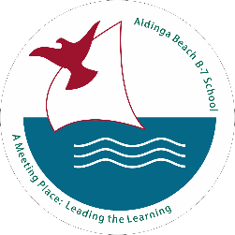

Aldinga Beach B-7 School
QUINLIVEN ROAD

ALDINGA SA 5173

PHONE: [08] 8556 5060

FAX: [08] 8556 5810

SCHOOL UNIFORM PRICE LIST

NAME OF STUDENT:

CLASS TEACHER NAME:

ITEM | SIZE | COST | QUANTITY REQUIRED | SIZE  REQUIRED | TOTAL
Polo Shirt | 4 – 14 | $30.00
Polo Shirt | S /M / L | $30.00
Middle Years Polo | 10 – 16 | $35.00
Boss Top with ¾ zip | 4 - 14 | $40.00
Boss Top with ¾ zip | S-M-L | $40.00
Dresses | 4 – 16 | $15.00
School Bucket Hat | S / M / L | $12.00
 |  |  | TOTAL |  | $
UNIFORM SHOP HOURS

Tuesday & Thursday MORNINGS
8:30am – 9:00am

